 

**Placement Empowerment Program**

***Cloud Computing and DevOps Centre***

Set Up a Local Git Repository: Initialize a Git repository locally and version control your static website

Name: Subiksha R Department: AML



**Introduction :**

Version control is an essential practice in software development that helps manage changes to source code over time. Git, a distributed version control system, allows developers to track changes, collaborate, and store code both locally and remotely. GitHub is a cloud-based platform for hosting and sharing Git repositories, enabling collaboration among developers. This task outlines how to initialize a local Git repository, connect it to a remote GitHub repository, and push local changes to GitHub.

**Overview :**

This task demonstrates the process of:

1. Setting up a local Git repository on your computer.
2. Committing project files to Git for version control.
3. Creating a remote repository on GitHub to host your project.
4. Connecting your local repository to GitHub.
5. Pushing the local code to the remote GitHub repository for backup and collaboration.

**Objectives :**

The primary objectives of this task are:

1. To learn how to initialize and use a local Git repository.
2. To understand how to set up a remote repository on GitHub.
3. To learn how to connect a local Git repository to a remote GitHub repository.
4. To push local changes to GitHub and ensure the repository is up-to-date.

**Step-by-Step procedure :**

**STEP 1 : Install Git.**

Search for "Git" in Chrome, download it, and click the "Downloads" option on the website.

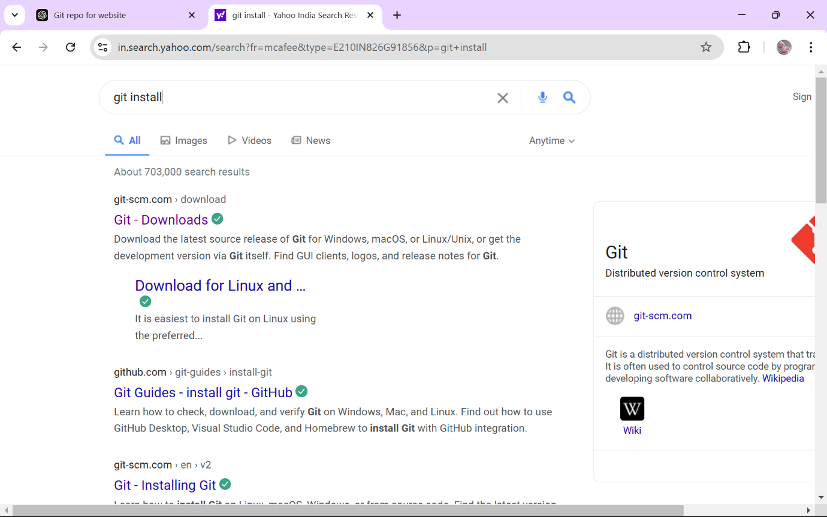

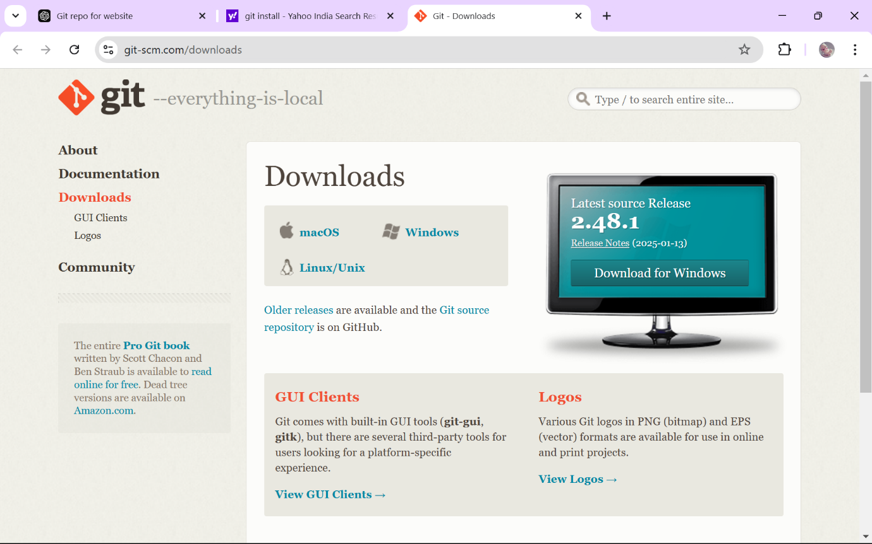

**STEP 2 :** Create a simple HTML file named index.html. You can write some basic HTML.

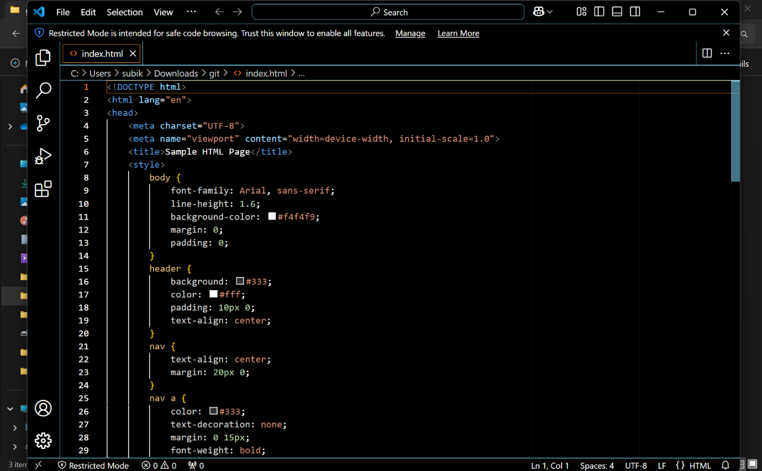

**STEP 3 : Create a Repository on GitHub.**

1. Go to [GitHub](https://github.com) and log in to your account.

2. Create a new repository with a name and description.

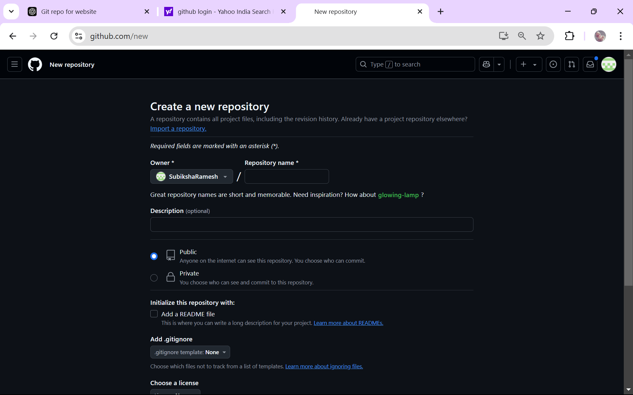

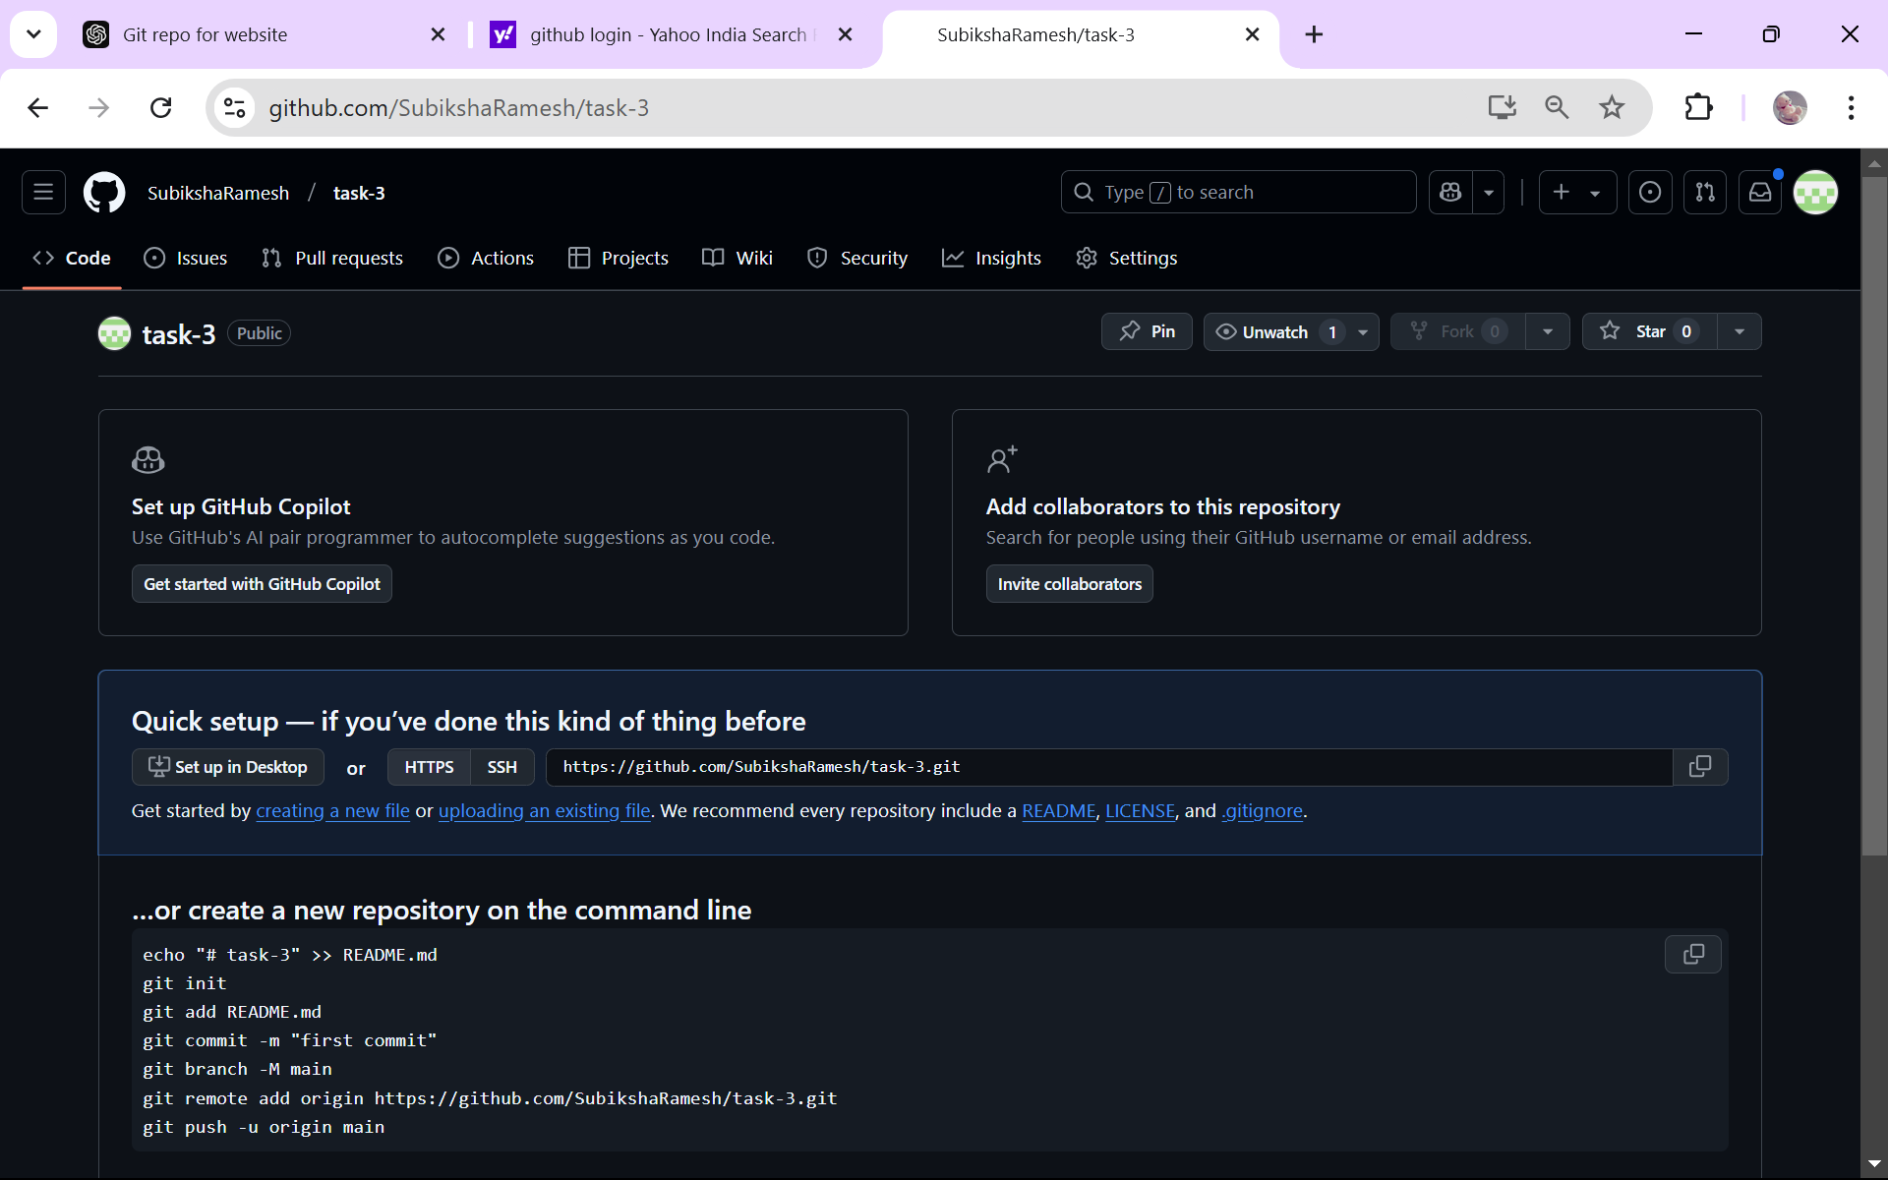

**STEP 4 :**  **Initialize the Local Git Repository.**

Open your terminal or Git Bash.

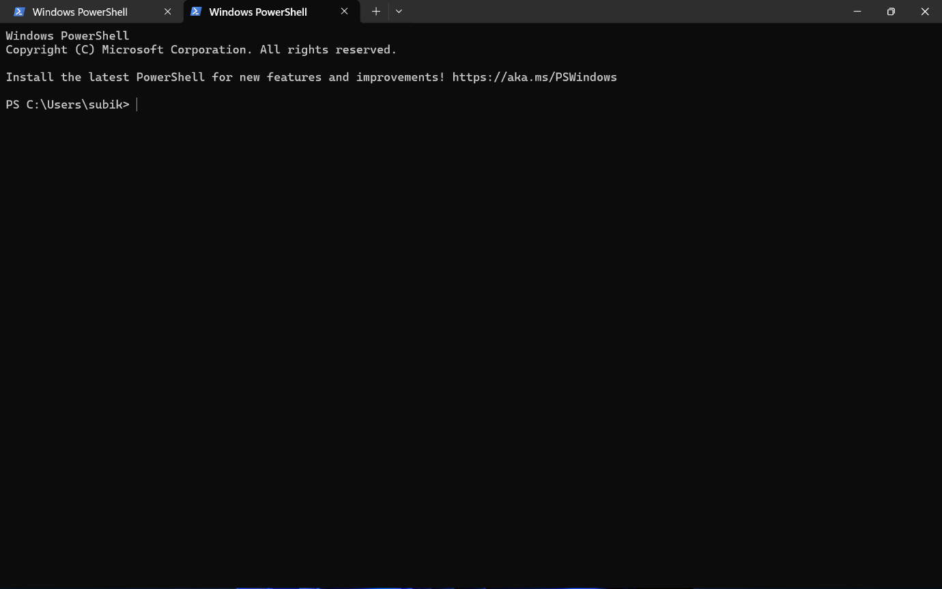

**STEP 5 : Check the version of the git.**



This confirms the version of Git currently installed on your system.

**STEP 6 : Initialize the Git repository.**



This creates a .git folder to track versions of your project.

**STEP 7 : Stage and Commit Your Files.**

Add all files to the staging area.



Commit the files with a message.



**STEP 8 : Connect the Local Repository to GitHub.**

Add the GitHub repository as a remote.



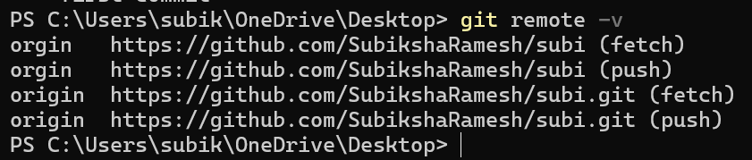

To check the log use git log commend,

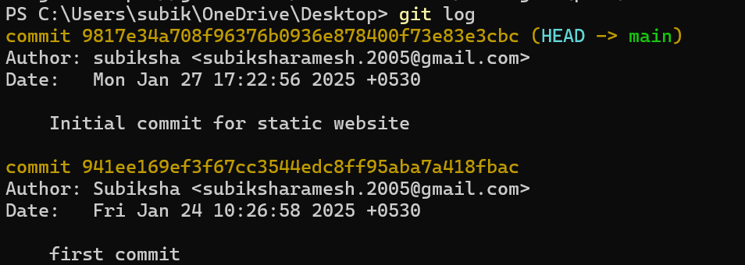

**STEP 9 :**

Verify Your Files on GitHub

Go to your GitHub Repository:

Open your web browser and navigate to your GitHub repository (e.g., https://github.com/yourusername/my-website).

You should see your website files there!

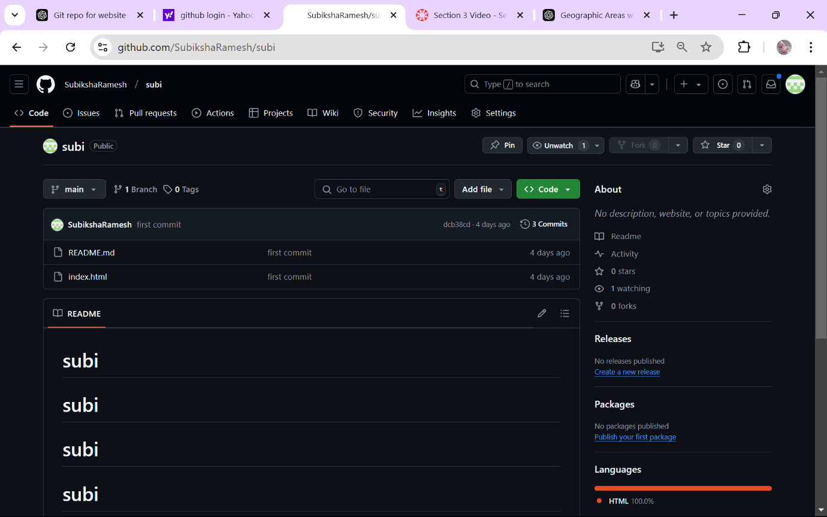

**Outcome :**

After completing these steps, you will have successfully:

1. Initialized a local Git repository to track changes in your project.
2. Committed your project files to the local Git repository.
3. Created and connected a remote GitHub repository to your local project.
4. Pushed your code to GitHub, making it available online for backup and collaboration.

This process ensures that your project is safely version-controlled and accessible from anywhere. Additionally, you can collaborate with other developers by pushing and pulling changes from GitHub.